TEST LOG FORM | Test Log No: 12
Test ID: SE-N17-012 | Test Date: 30/01/2013
Tester: Tom | Group: 17
Version When Tested:
Test Passed? (Y/N): Y
Passed Testing 1st[X],2nd[ ],3rd[ ],4th[ ] time.
Other…………
Description of test: Attempt to create a new user but enter different passwords into the two password boxes provided.

Proof of testing:
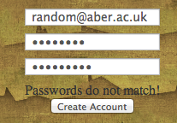

Comments: Test passed on first attempt.
The following section only applies if the test failed and changes needed to be made. If change need to be made a change control form needs to be completed documenting this. The details of that form also need to be highlighted below.
Change Control Number:
Description of changes made:

